Installation & Testing Instructions   
Earthdata Bulk Downloader



May 12, 2020

# Installation steps

**Step 1:**

Clone the git repository to your local desktop:

* <https://git.earthdata.nasa.gov/projects/GHRC/repos/bulk-download/browse>

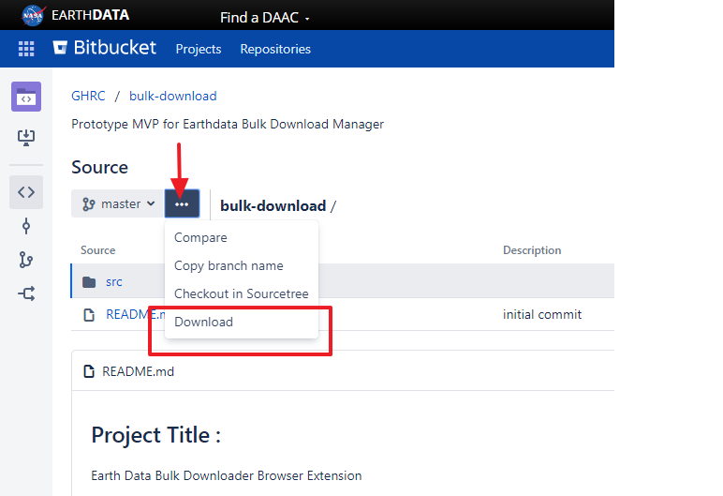If you’re not able to download as depicted in the above screenshot, you can use your desktop’s command prompt to clone by typing the following command:

git clone<https://git.earthdata.nasa.gov/scm/ghrc/bulk-download.git>

Warning: Make sure you have git installed on your local machine to clone it from the command prompt. If not, can be installed from this [link](https://git-scm.com/download/win)

**Step 2:**

Locate the git cloned folder(must be in the Downloads folder). It is a zip file with the name **“bulk-download-master@xxxxxxx.zip”.** Unzip the folder and check if it has a folder structure with a **“manifest.json”** file in src folder as shown below:

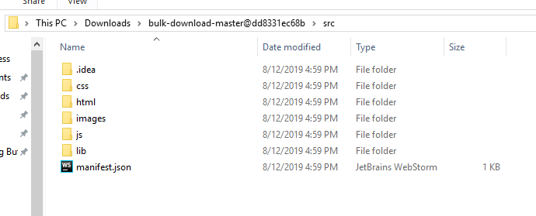

# Follow the links for your favorite browser:

* Chrome Browser
* Firefox Browser

# 

# Firefox Browser:

**Step 3:**

Open Firefox browser, open the temporary add-ons page by typing “about:debugging” in the address bar and click on the “Load Temporary Add-on” button.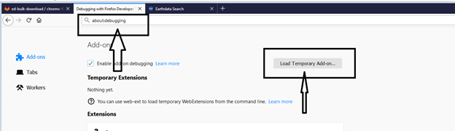

**Step 4:**

Browse to the git cloned folder, navigate to src folder and open the manifest file (inside the src folder). The Bulk Downloader extension is now set up on firefox and is ready to be tested.

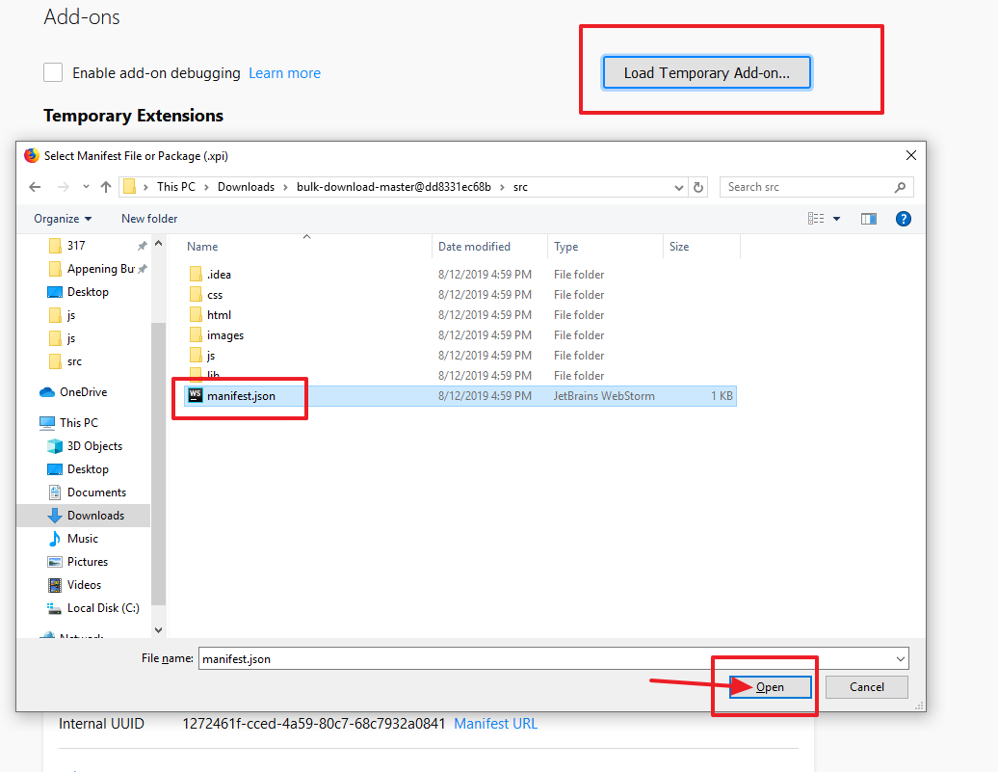

Warning: Please do not close the “about:debugging” page in Firefox during testing. Kindly use a new tab for Earthdata Website. (Once the firefox browser is closed, since the add-on is a temporary extension for developers, it gets deleted. This is not the case for Chrome browser though.)

**Step 5:**

For initial testing, here’s an example dataset with temporal and spatial filters applied already, available at this [link](https://search.earthdata.nasa.gov/search/granules?p=C1607549631-ASIPS&sb=16.3125%2C69.56497416188165%2C18.56253433227539%2C71.5333185964075&m=56.674845391312594!-29.320312500000004!3!1!0!0%2C2&qt=2020-05-04T11%3A14%3A43.010Z%2C2020-05-04T15%3A57%3A20.424Z&ff=Map%20Imagery&tl=1576948028!4!!).

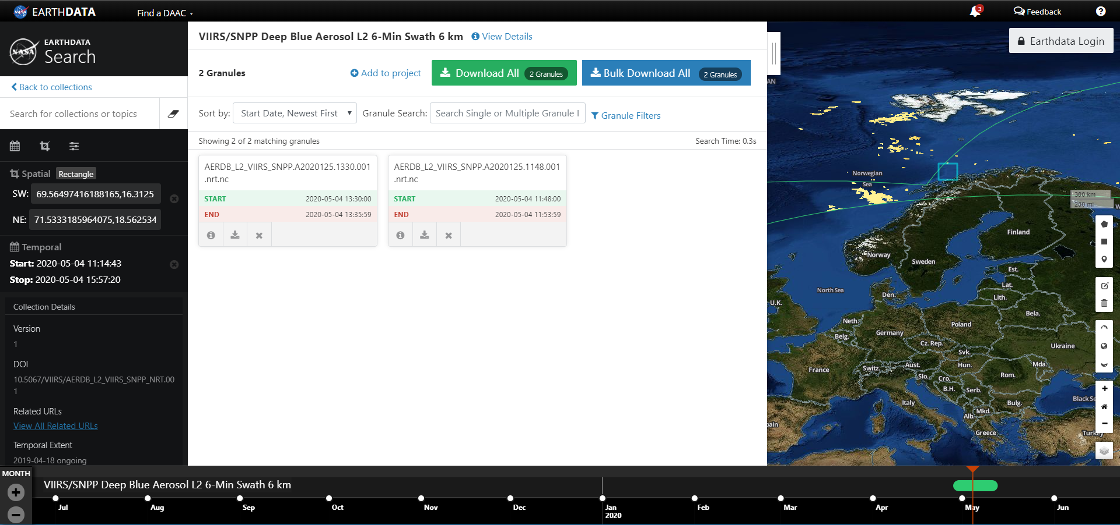

On clicking the **Bulk Download All** button, if not logged in to the domain of the dataset server, it asks you to login to “URS” using a popup window (make sure your browser allows pop-ups) and then downloads all granules. If already logged in, it directly downloads the granules.

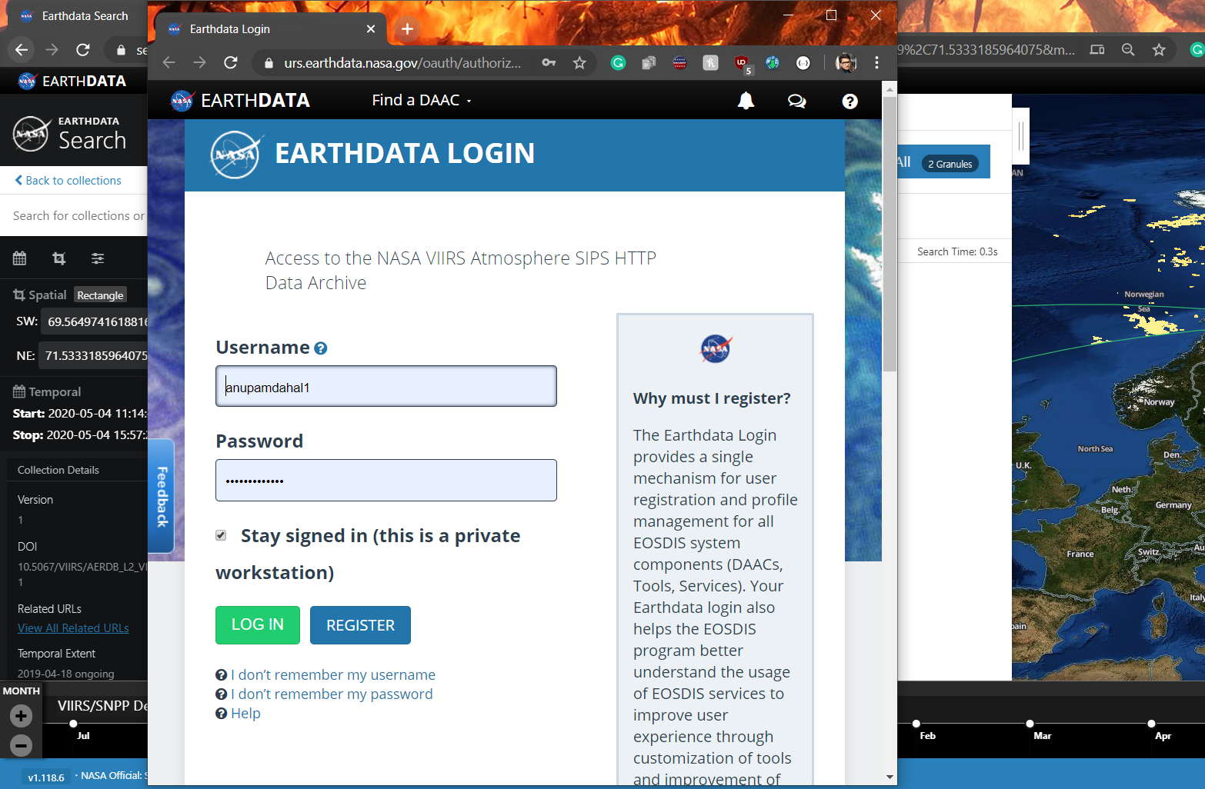

After clicking **Bulk Download All** button, it downloads 2 granules in your local downloads folder:



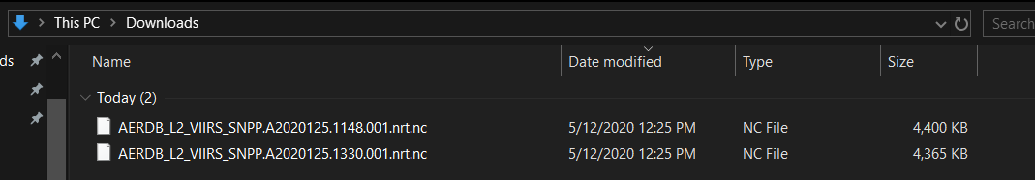

**Step 6:**

Once step 5 works fine, you can start searching for any dataset you wish to and narrow it down to fewer granules using temporal and spatial filters.

For Temporal Filters, click on Granule filters and enter the Start and End Date-Time and click on Apply (as shown in the screenshot below). The dataset gets filtered according to the set date and time. For instance, here the dataset: “VIIRS/SNPP Deep Blue Aerosol L2 6-Min Swath 6 km” has been used, and after applying date filters as shown below, here is the [link](https://search.earthdata.nasa.gov/search/granules?p=C1607549631-ASIPS&pg%5B0%5D%5Bqt%5D=2020-05-02T00%3A00%3A00.000Z&m=-1.1243648281515277!-64.40625!1!1!0!0%2C2&ff=Map%20Imagery&tl=1576948028!4!!) to the dataset.

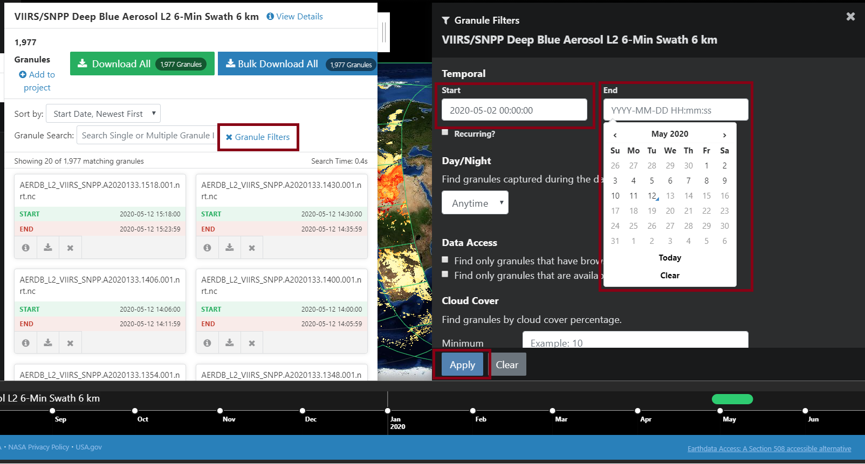

**Step 7:**

The spatial filters like the Polygon, Rectangle or Point plots can be used to filter the granules as well. First, click on the icons in either side of the screen as highlighted below and select Polygon /Rectangle/Point (Currently File and Grid Coordinates are not included in the extension)

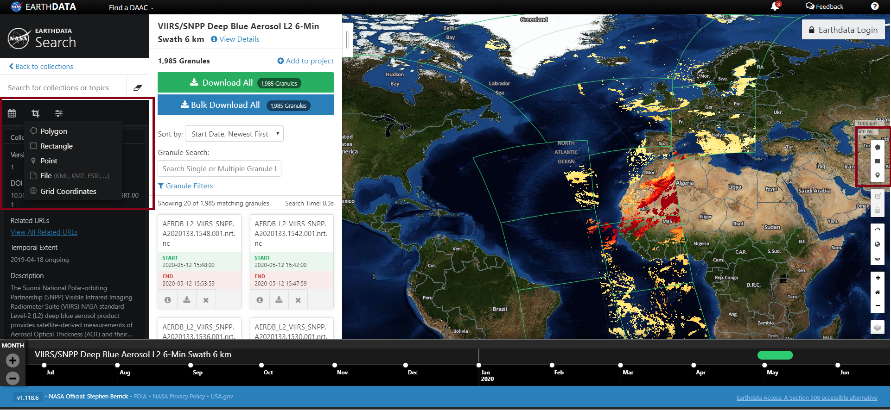

In the same example from step 6, click the rectangle from above screenshot and draw a rectangular plot as shown below. The granules get narrowed down further to 4(along with the temporal filters applied in Step 6). [Here is the link to the example](https://search.earthdata.nasa.gov/search/granules?p=C1607549631-ASIPS&sb=-19.406232833862305%2C-3.878381253104721%2C-17.999982833862305%2C-2.1914090528581767&m=-5.1141358647283255!-29.28515625!4!1!0!0%2C2&ff=Map%20Imagery&tl=1576948028!4!!).

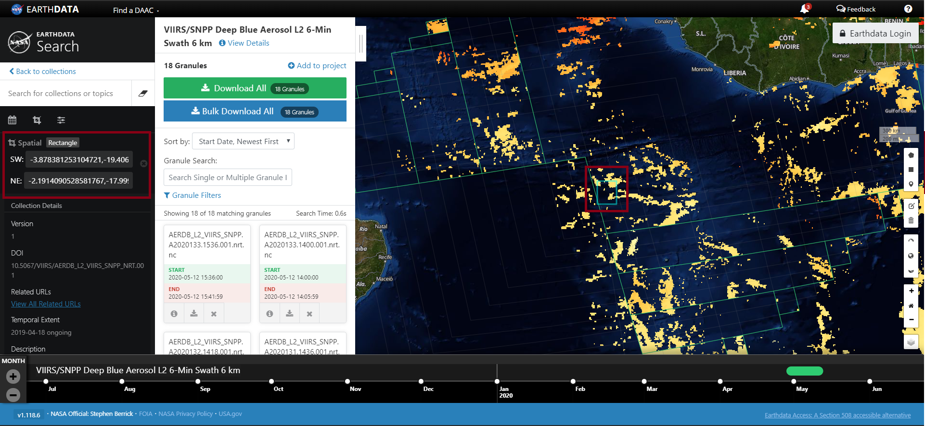

As described in step 5, On clicking the **Bulk Download All** button, if not logged in, it asks you to login to “URS” using a popup window (make sure your browser allows pop-ups) and then downloads all granules. If already logged in, it directly downloads the granules in your local downloads folder.

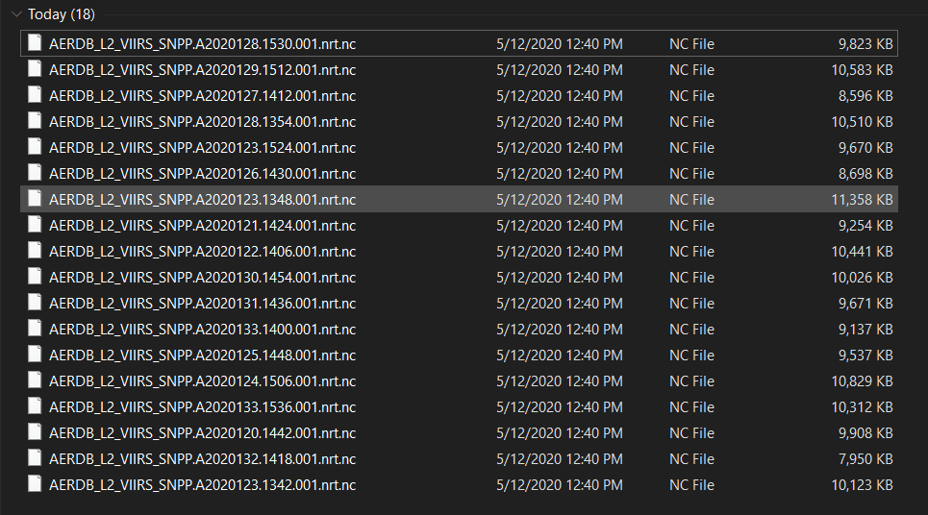

You can repeat these steps for different datasets.

# Chrome Browser:

After you are done with Step 1 and 2 from above, follow the steps below for Google Chrome.

**Step 3:**

On opening Chrome, open the extensions page by typing “chrome://extensions” in the address bar or from settings → more tools → Extensions.

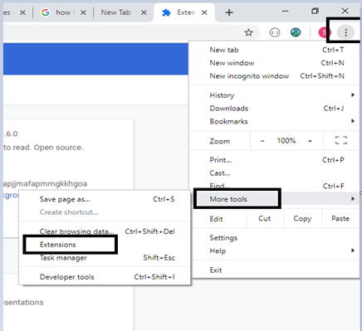

**Step 4:**

Switch on the Developer mode on the top right corner of the page.

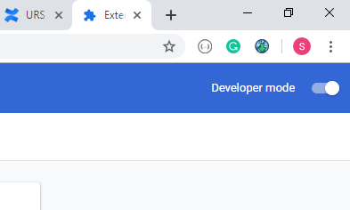

Click on “Load unpacked” and Browse to the git cloned folder, navigate to **src** folder and click on "Select Folder".

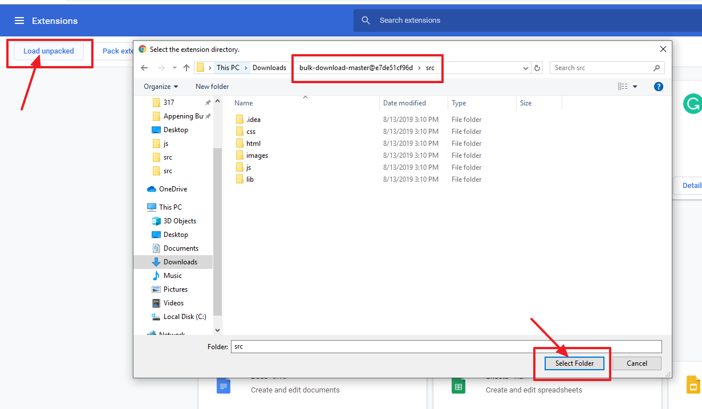

The extension has been installed and is ready to be tested in the Google Chrome browser.

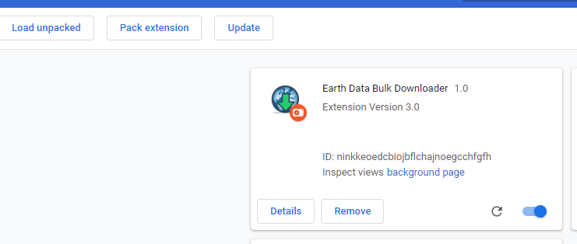

**Step 5:**

For initial testing, here’s an example dataset with temporal and spatial filters applied already, available at this [link](https://search.earthdata.nasa.gov/search/granules?p=C1607549631-ASIPS&sb=16.3125%2C69.56497416188165%2C18.56253433227539%2C71.5333185964075&m=56.674845391312594!-29.320312500000004!3!1!0!0%2C2&qt=2020-05-04T11%3A14%3A43.010Z%2C2020-05-04T15%3A57%3A20.424Z&ff=Map%20Imagery&tl=1576948028!4!!).



On clicking the **Bulk Download All** button, if not logged in to the domain of the dataset server, it asks you to login to urs using a popup window(make sure your browser allows pop-ups) and then downloads all granules. If already logged in, it directly downloads the granules.



After clicking **Bulk Download All** button, it downloads 2 granules in your local downloads folder:





**Step 6:**

Once step 5 works fine, you can start searching for any dataset you wish to and narrow it down to fewer granules using temporal and spatial filters.

For Temporal Filters, click on Granule filters and enter the Start and End Date-Time and click on Apply (as shown in the screenshot below). The dataset gets filtered according to the set date and time. For instance, here the dataset: “VIIRS/SNPP Deep Blue Aerosol L2 6-Min Swath 6 km” has been used and after applying date filters as shown below, here is the [link](https://search.earthdata.nasa.gov/search/granules?p=C1607549631-ASIPS&pg%5B0%5D%5Bqt%5D=2020-05-02T00%3A00%3A00.000Z&m=-1.1243648281515277!-64.40625!1!1!0!0%2C2&ff=Map%20Imagery&tl=1576948028!4!!) to the dataset.



**Step 7:**

The spatial filters like the Polygon, Rectangle or Point plots can be used to filter the granules as well. First, click on the icons in the either side of the screen as highlighted below and select Polygon /Rectangle/Point (Currently File and Grid Coordinates are not included in the extension)



In the same example from step 6, click the rectangle from above screenshot and draw a rectangular plot as shown below. The granules get narrowed down further to 4(along with the temporal filters applied in Step 6). [Here is the link to the example](https://search.earthdata.nasa.gov/search/granules?p=C1607549631-ASIPS&sb=-19.406232833862305%2C-3.878381253104721%2C-17.999982833862305%2C-2.1914090528581767&m=-5.1141358647283255!-29.28515625!4!1!0!0%2C2&ff=Map%20Imagery&tl=1576948028!4!!).



As described in step 5, On clicking the **Bulk Download All** button, if not logged in, it asks you to login to “URS” using a popup window (make sure your browser allows pop-ups) and then downloads all granules. If already logged in, it directly downloads the granules in your local downloads folder.



You can repeat these steps for different datasets.

Multiple Datasets:

1. On the Earthdata Website, add Datasets using the “+” Button (remove by using “-” button) and Click on My Project.

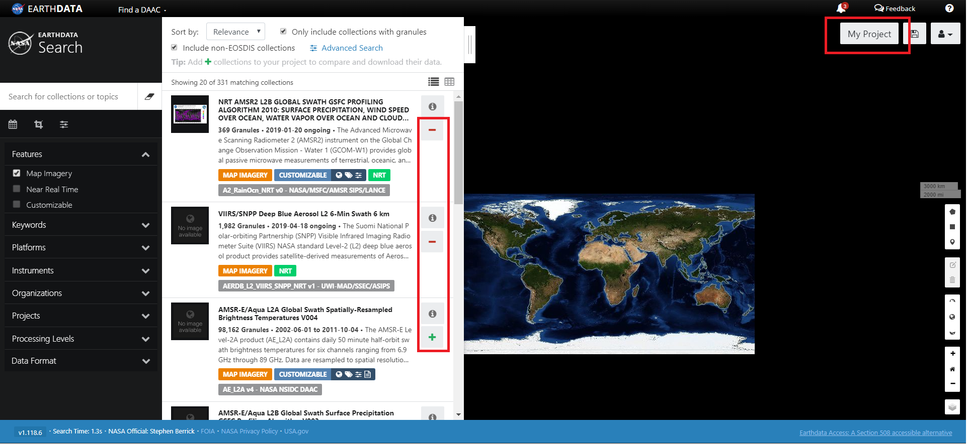

1. Temporal and Spatial filters can be applied in a similar way as it is done for individual datasets explained above in step 6 and 7.

Temporal filter:  
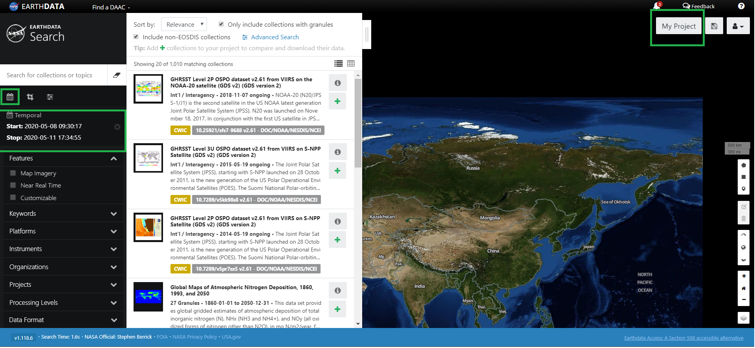  
Spatial filter:  
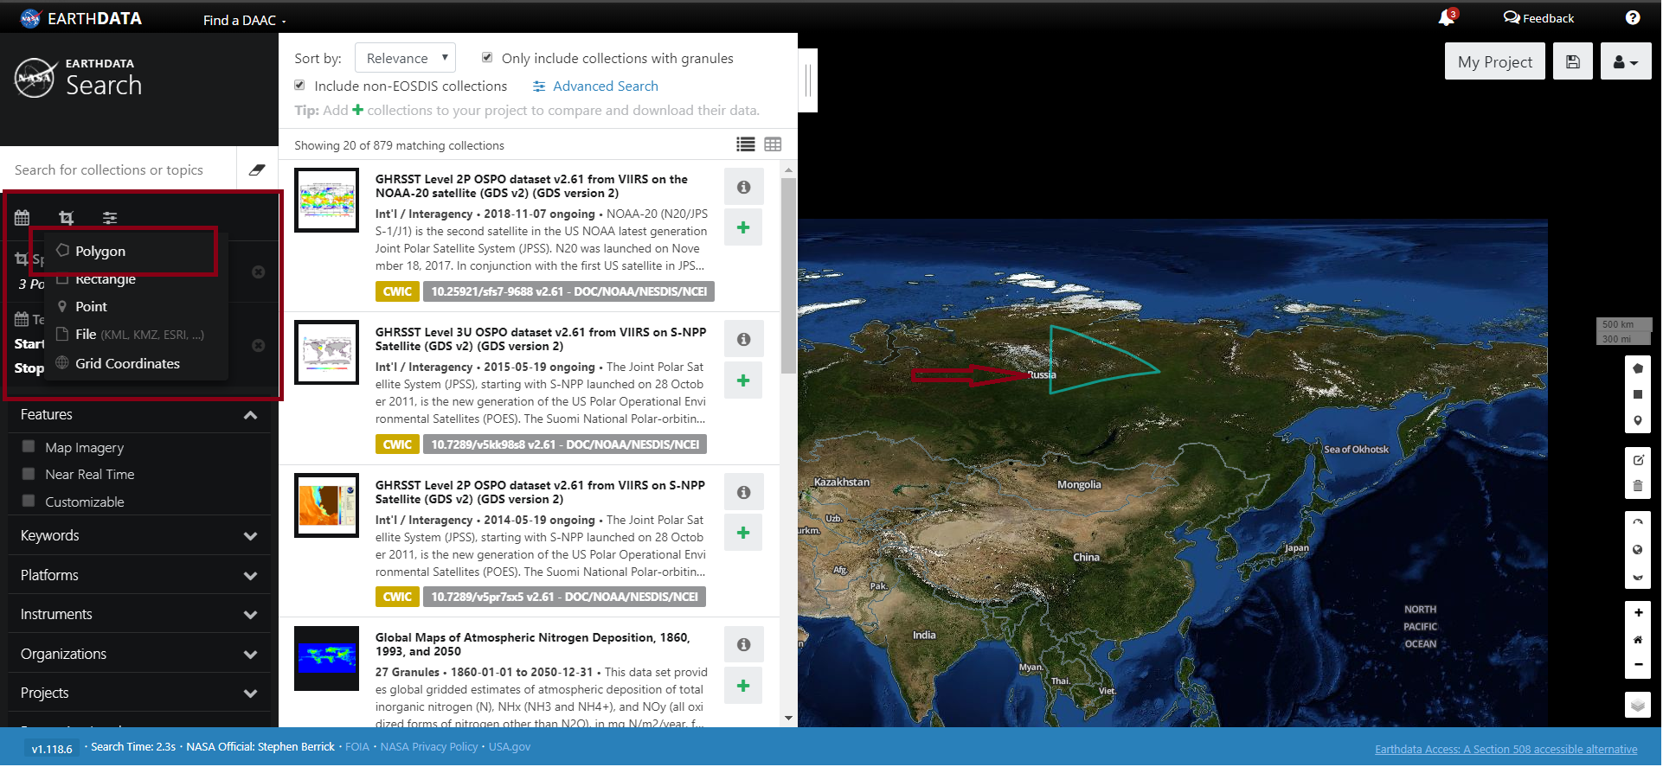

1. A new button, Bulk Download All is appended to ease the downloading of all the datasets in the project at once.

